EF CORE 8.0 Solved Exercise

LAB 1: Understanding ORM with a retail Inventory system:
Output:
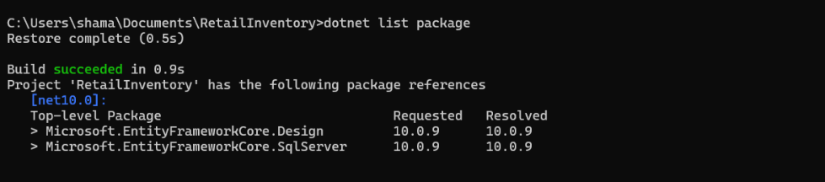

LAB 2: Setting Up the database context For a retail store:

Product.cs:

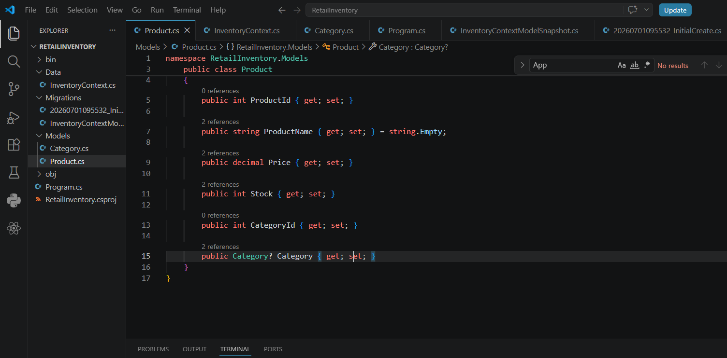

Category.cs:
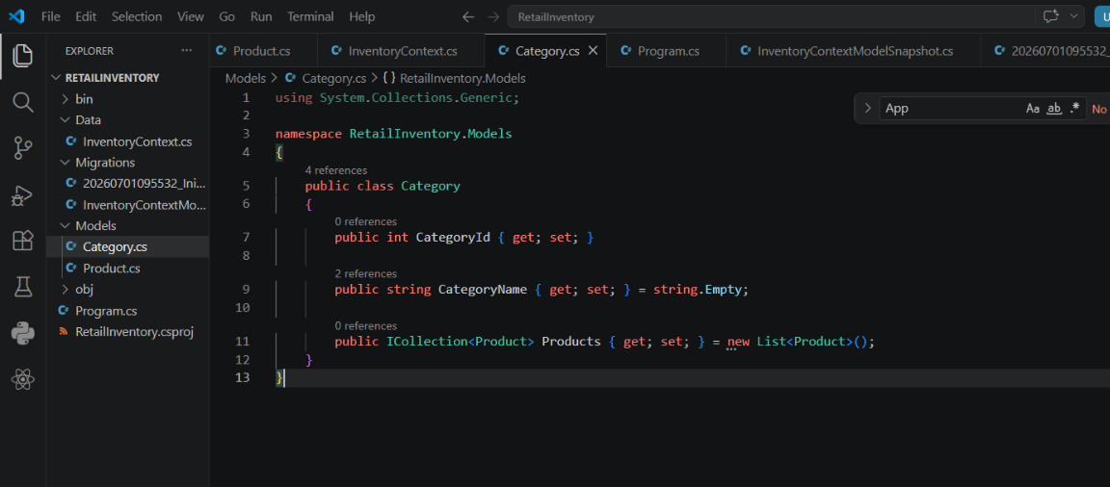

InventoryContext.cs:
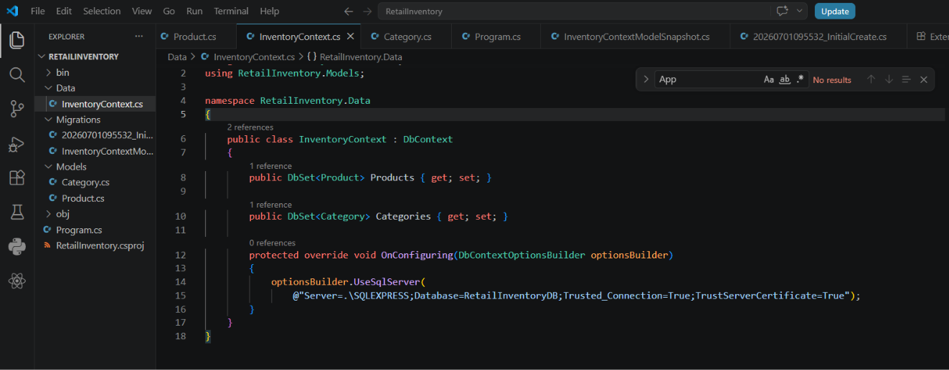

LAB 3: Using EF Core CLI to create and apply migrations:
Output:
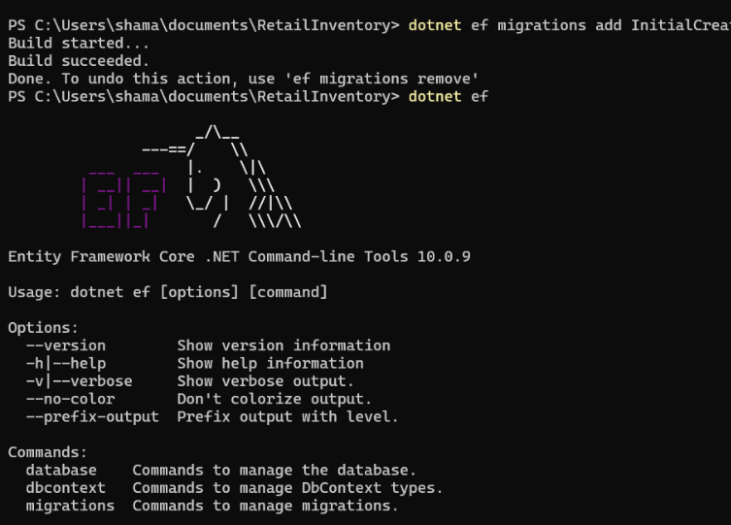
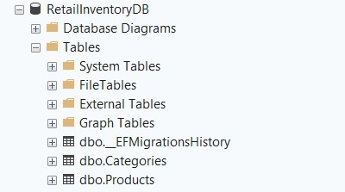

LAB 4: Inserting initial data into the database:
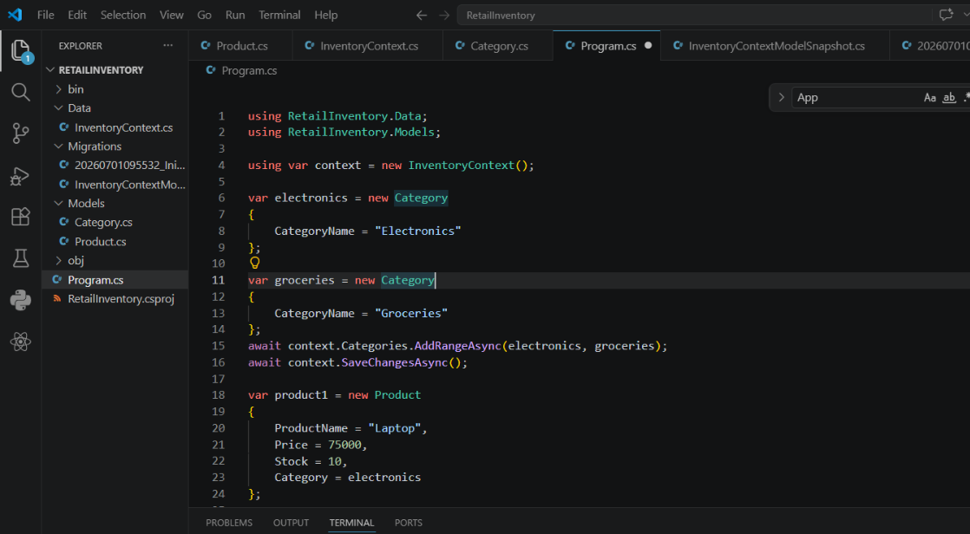

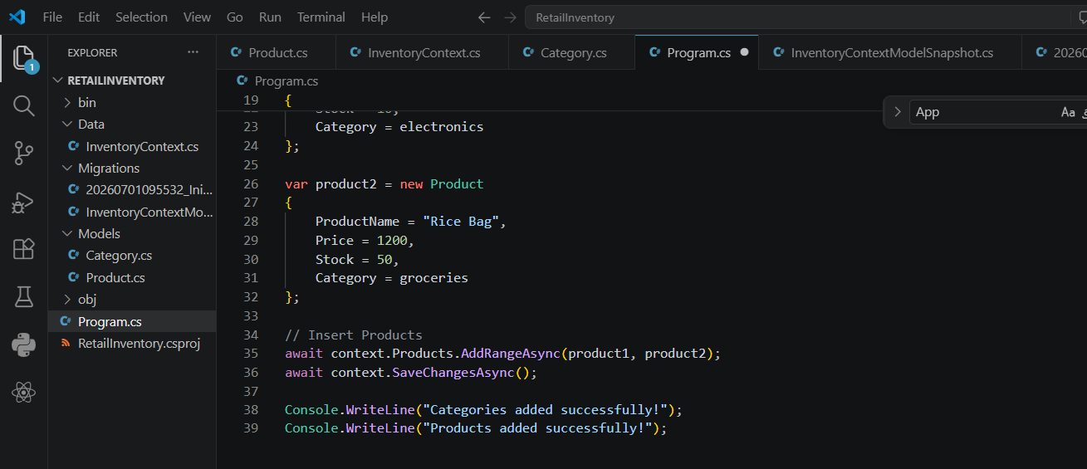

Output:

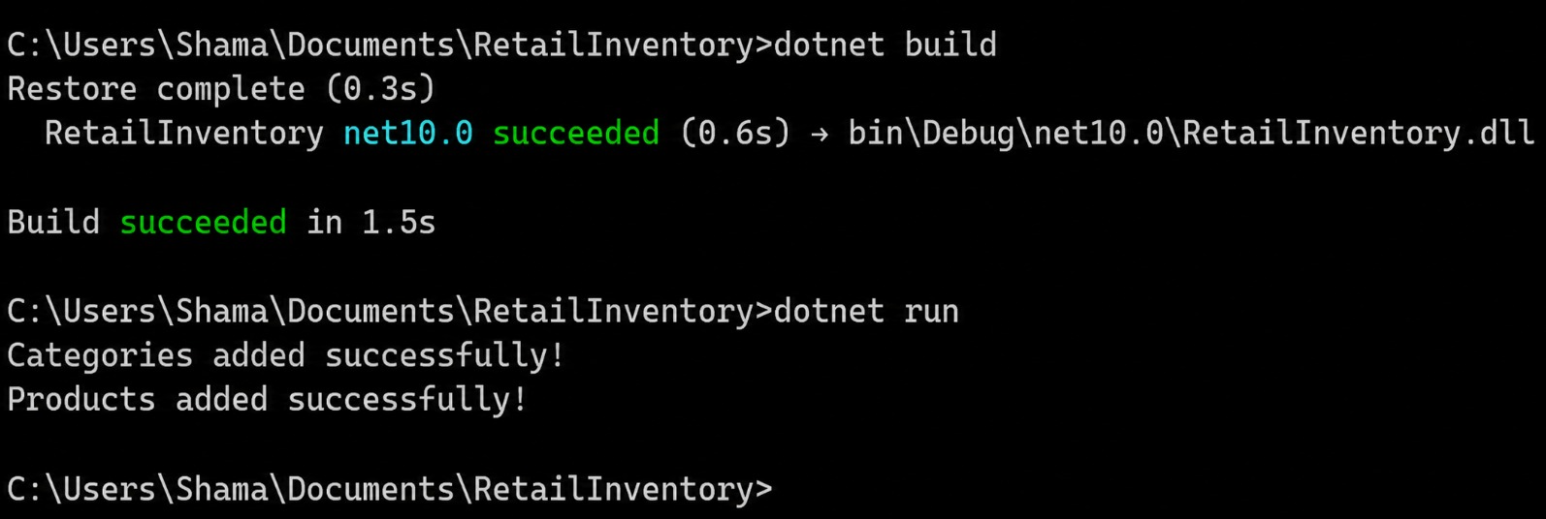

LAB 5: Retrieving Data from the database:

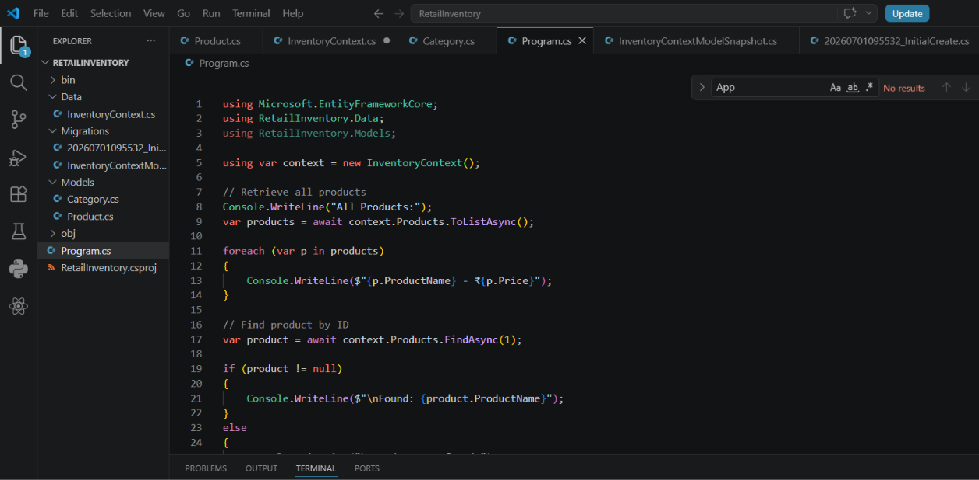

Output:
